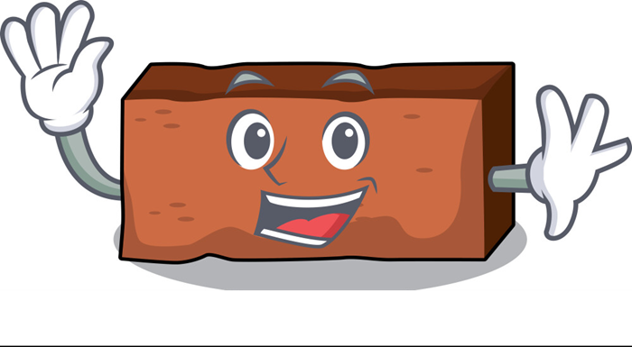
The Brick
by Claudia Lemus
I was out walking one Sunday, hurrying along a street in the suburbs of Buenos Aires. I didn't want to be late for family lunch at nonnas house. Every Sunday we ate her home-made ravioli.
She started cooking on Saturday afternoon, preparing the filling and the suco, or sauce—it was delicious! You could smell the delicious aroma as soon as you arrived at her house.
As I passed by a house that had been demolished some time ago, I heard someone whispering:
“Chist! Chist!
I turn around and see no one. I look carefully in all directions and find myself alone on the sidewalk. There are no people across the street either. I keep walking, thinking it must have been my imagination.
Again: “Chist! Chist!”
I look down and see nothing.
I'm getting impatient. Nonna doesn't like us to be late for lunch when Tutta la famiglia is gathered together.
I take another step and hear: “Down here, I said, I'm a brick.”
Well, now things were getting interesting. And I said quietly to myself, “And I'm the Nobel Prize winner for literature.”
But sure enough, the voice seemed to be coming from a brick. "I'm in a hurry," I answered it.
“Ah, lucky you, you can go wherever you want. Here I am, always in the same place. Some people are so lucky...” And he immediately added: “Would you take me with you? I see you have a spacious backpack...”
Tired of this conversation, I answered: "OK, I'll take you. But you must promise to be quiet in Nonna's house."
"Don't worry, young man, not a word will emerge from this mouth."
I picked it up, put it in my backpack and continued on my way.
When I arrived at my grandmother's house, she first looked at me with a frown, then hugged me, smiling and said, “You're finally here, my dear. We were waiting for you. And everyone is dipping bread in the succo, even though I told them to save some for the ravioli.
I left my backpack by the door. I greeted everyone with a kiss and we sat down to eat.
In the evening, after the big meal, we said goodbye with hugs and kisses until next Sunday. The brick didn't chist to anyone. It kept its word.
I got home and left my backpack in my bedroom. When I took the brick out, it protested a little: "It seems that the family gathering was a success. From my dark backpack, I could hear laughter and giggling.“
I left it on the floor without answering.
The brick asks:
“Where are you going to put me? I'd say that shelf would give me a good view out of the window. What do you think?”
I was getting a little tired, so I put it where it so subtly indicated. Let's see if we can get this conversation over with once and for all. And I got ready for bed.
The next morning I had my usual breakfast: green tea and cereal with fruit.
I started typing on my laptop. Less than five minutes later, I heard: “Buenos días!” It was the brick again. “Nice day, huh? I'm curious, what are you writing?”
“I'm trying to write a story,” I say without looking at it.
“Ah, that's what I thought when I saw you walking toward me on Sunday. You have the face of a writer...”
“I don't do this for a living, it's just a hobby. But yes, I would like to have something published someday,” I reply without stopping typing.
“Sure, sure. I understand. But give it time. You'll see that I'm right,” says the brick.
He waits a few minutes and then starts talking again.
“If you tell me what you're writing about, I could give you my opinion on it.”
“No, thanks,” I say, losing patience.
This chatty brick is worse than a chatty parrot. At least they say that if you cover a parrot's cage with a cloth or a piece of fabric, it stays quiet because it understands that it's time to rest. The brick stayed quiet for about three minutes, no more. I was timing it with the clock on my computer.
"I could tell you so many stories for you to write about. Very interesting ones! Oh, how interesting they would be! And with the advantage for you that I wouldn't claim authorship. You could put your name on them. What did you say your name was, sir...?"
"I didn't tell you my name, “Mr. Brick.” Now please be quiet.
He must have realized that he was going too far, because this time he was silent for about ten minutes, no more. And he began to hum a tango. He became more and more emboldened and hummed louder and louder. And he had an extensive repertoire.
I gritted my teeth, to see if that would help me concentrate better on my work.
Then he added, as if distracted:
"Do you know that you have an extraordinary ability? Yes, you should be very proud of that ability."
I continue as if nothing happened.
"Aren't you curious to know what it is?"
With no patience left, I leave the keyboard, turn around to look at him, and say:
“Whatever that skill is, it's definitely not the ability to write a story. Because since I began this one, you haven't stopped talking. And I can't concentrate!”
"But communication is very important, like empathy. Don't you agree? I was referring to your great ability to listen to me. Until now, no one had ever listened to my whispers. And I even whispered to dogs. And I'd rather not tell you how the dogs reacted to me. You are the first person who has ever listened to me since I started talking. And I've been talking for as long as I can remember."
"So I'm the only one who listens to you?" I answer thoughtfully. "That's a compliment to my ego. For example, when I have to write my resume after I finish my studies, I will write: “I have a special and very useful skill.” In the languages section, I'll write: “I understand bricks.” Wait, let me write that down. Does the language of bricks have a special name? Great! When I tell my grandmother this Sunday, maybe she'll give me a bigger serving of ravioli. She gets very happy with my achievements."
"You know what, Mr. Brick? We're going to celebrate with a walk. I'll put you in this bag. Look at this beautiful bag with Tote bag written in emerald green! That way you'll travel comfortably. Do you agree?"
-"Yes, yes, of course. I'll travel like a king,"said the brick, satisfied.
"You said it". I replied.
I walked a few blocks to an empty lot and quickly took the brick out of my bag. Without giving him time to say a word, while he looked around, I started running toward my house. I arrived out of breath and locked the door. From the garden, I could hear my mother's voice saying:
“Lorenzo, is that you, son? Are you back already?”
"Yes, Mom, I changed my mind. I'd better stay home. I have homework for tomorrow. I have to hand in a story to get my grade up.“
"Have you already written it?"

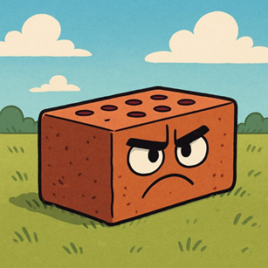
"No, but it won't take me long now."

Translated from Spanish by F T Smith
Español (link)

